Security testing
Requirement 1
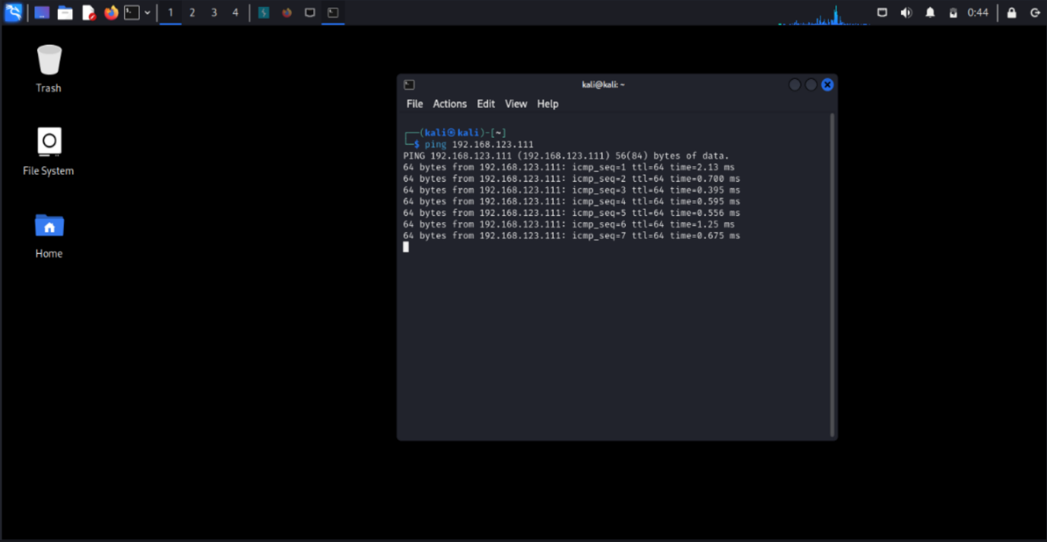
Figure 1 this is how I ping device
Requirement 2

